AGM 2013
The Annual General Meeting of the Religious History Association was held at Macquarie University on 31July 2013.
It is with pleasure that we announce the results of the election to the Committee of Management of the Religious History Association for a two-year term from July 2013 to June 2016.
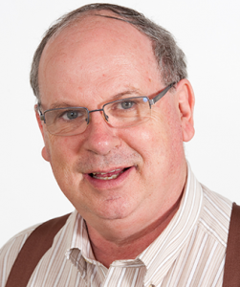
President : Scientia Professor, John Gascoigne, UNSW, School of Humanities and Languages, NSW
As incoming president of the Association I would like to both salute and farewell my predecessor, our founding president, Hilary Carey. Hilary was the leading spirit in the creation of the Religious History Society in 1998 and played a major role in the merger between it and the Association for the Journal of Religious History to form the Religious History Association in 2010. She has served in many of the different roles which the Association now encompasses: journal editor, conference organiser (on multiple occasions) and committee member. As President she did much to establish many of the features which give the Association a public face: this website, the newsletter and the online discussion group. The Association wishes her every success in her new post as Head, School of Humanities, Bristol University, UK.

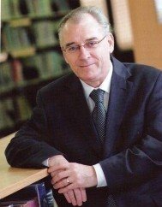
Vice President: Associate Professor Glen O'Brien, Research Coordinator, Eva Burrows College, University of Divinity, Melbourne.
Associate Professor Glen O'Brien is Research Coordinator and a Lecturer in Christian History and Wesleyan Studies at Eva Burrows College within the University of Divinity and a member of the University of Divinity's Centre for Research on Religion and Social Policy. He is a Uniting Church minister in the Yarra Yarra Presbytery with a placement to full time theological education in The Salvation Army. Glen formerly served as Head of Humanities, Head of Theology, and Senior Lecturer in Church History at Booth College.

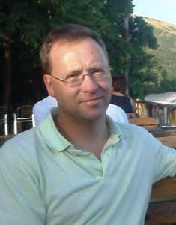
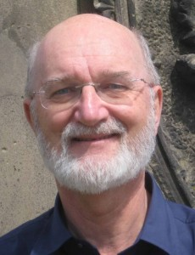

Secretary: Dr Ian Tregenza,
Macquarie University

Treasurer: Professor Malcolm Prentis,
Australian Catholic University

MEMBERS:
- Professor Philip Almond, University of Queensland
- Dr Joanna Cruickshank, Deakin University
- Professor Peter Harrison, University of Queensland
- Professor Shurlee Swain FASSA, Australian Catholic University
- Leigh Penman, University of Queensland

JOURNAL OF RELIGIOUS HISTORY

The Editors of the Journal of Religious History are ex officio members of the RHA Committee of Management. Professor Carole M. Cusack and Dr Christopher Hartney were confirmed for a fourth and final two-year term as Editors of the Journal.
The Committee also elected Associate Professor Stuart Piggin as a Fellow of the Religious History Association. The nomination will follow shortly and can be read on our Fellows page.
As outgoing President of the Religious History Association, Professor Hilary Carey sends her congratulations to all those who have agreed to serve on the RHA Committee of Management. Hilary sends thanks also to the Editors of the Journal of Religious History, Josip Matesic, organiser of the RHA contribution to the Wollongong meeting of the Australian Historical Association. Their efforts over the last two years have helped make the Association stronger in terms of its finances, activities and publications, including the Journal of Religious History, TheRHA (the newsletter edited by Anna Haunton), and the new conference publication series, the first volume of which, edited by Christopher Hartney, will be published by Cambridge Scholars Press later this year.
Hilary looks forward to continuing her attachment to the Association as a member and subscriber to the Journal of Religious History when she moves to the UK next year.
The Minutes - AGM-31-July- 2013-RHA Minutes

