AGM 2016
Outgoing President, Scientia Professor John Gascoigne, reported the following:
The new committee is in place with Constant Mews as President, Katharine Massam as Secretary and Kerrie Handasyde as Treasurer (Peter Price had to withdraw because of illness). Other members of the committee remain the same: Glen O’Brien, vice-president, and Shurlee Swain and Leigh Penman committee members along, of course, with the two editors, Jason Taliadoris and Joanna Cruickshank.
As regards the recent meeting the main other news item was that the RHA are giving a $6000 grant to support the following workshop:
Laura Radmaker (ACU) and Christina Petterson (Newcastle)
‘What God has joined together: Histories of religion and marriage’ to be held at the University of Newcastle in July 2017. This will proceed the annual Australian Historical Association conference at which the RHA plans to include its customary strand.
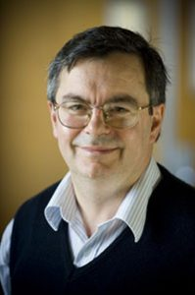
President: Professor Constant Mews, Director, Centre for Religious Studies
Constant J. Mews gained his BA and MA from the University of Auckland, New Zealand, and his DPhil from Oxford University. He is Professor within the School of Philosophical, Historical and International Studies, Monash University where he is also Director of the Centre for Religious Studies. He has published widely on medieval thought, ethics, and religious culture, with particular reference to the writings of Abelard, Heloise, Hildegard of Bingen and their contemporaries, including Abelard and Heloise (New York: Oxford University Press, 2005) and The Lost Love Letters of Heloise and Abelard. Perceptions of Dialogue in Twelfth-Century France, 2nd edn (New York: Palgrave-MacMillan, 2008). His research interests range from the early middle ages to late medieval religious and intellectual culture, as well as the interface between various religious and ethical traditions.

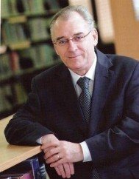
Vice President : Associate Professor Glen O'Brien, Research Coordinator, Eva Burrows College, University of Divinity, Melbourne.
Associate Professor Glen O'Brien is Research Coordinator and a Lecturer in Christian History and Wesleyan Studies at Eva Burrows College within the University of Divinity and a member of the University of Divinity's Centre for Research on Religion and Social Policy. He is a Uniting Church minister in the Yarra Yarra Presbytery with a placement to full time theological education in The Salvation Army. Glen formerly served as Head of Humanities, Head of Theology, and Senior Lecturer in Church History at Booth College. He is also Conjoint Senior Lecturer in the School of Humanities and Social Sciences at the University of Newcastle. His research areas include Australian Methodism and the political writings of John Wesley. He is a Research Fellow and Secretary of the Australasian Centre for Wesleyan Research http://acwr.edu.au/fellows/research-fellows/glen-obrien and he is the editor of The Journal of Wesleyan Thought (formerly Aldersgate Papers) the peer reviewed journal of the ACWR and has recently completed a full length monograph on John Wesley’s political writings. Along with Professor Hilary Carey he has co-edited a scholarly history of Australian Methodism which was published by Ashgate in 2014.

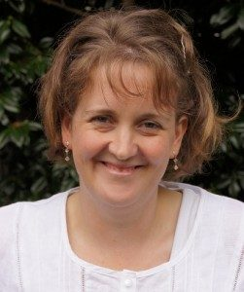
Treasurer: Kerrie Handasyde, Adjunct Lecturer in Church History at the University of Divinity
Kerrie teaches church history at the University of Divinity. Her current research focuses on literature, landscape and the Nonconformist tradition in Australia. Publications include scholarly articles on liturgy, spirituality and nineteenth-century church development, and a number of commissioned histories. Kerrie served as Honorary Historian for the Conference of Churches of Christ in Victoria and Tasmania (2008-2013) and Editor of ‘Historical Digest’ for the Australian Churches of Christ Historical Society (2001-2014).

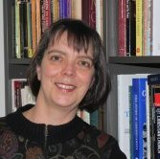
Secretary: Dr Katharine Massam
Dr Katharine Massam is Professor of Church History at Pilgrim Theological College in Melbourne, and teaching within the University of Divinity. She writes and teaches on a range of themes in the history of Christian spirituality, with a particular interest in Australia. She holds a doctorate in history from the University of Western Australia, and has also studied in the School of Education at Flinders University (Adelaide) and at the School of Theology, St John’s University (Collegeville, MN). Her publications include Sacred Threads: Catholic Spirituality in Australia (UNSW Press, 1996), On High Ground (UWA Press, 1996), as well as a number of scholarly articles and a forthcoming monograph on the Spanish Benedictine Missionary Sisters of New Norcia.

RHA Attached documents:
The Minutes - RHA Minutes July 2016-Final

